 | RoHS |  |  | HF |  | REACH
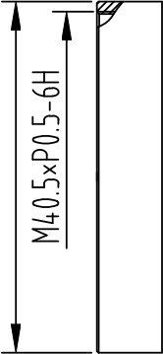

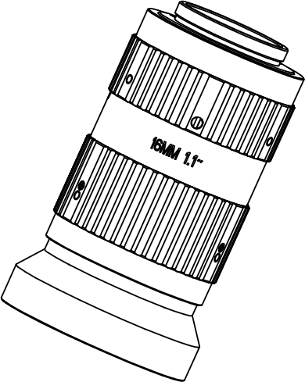
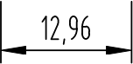
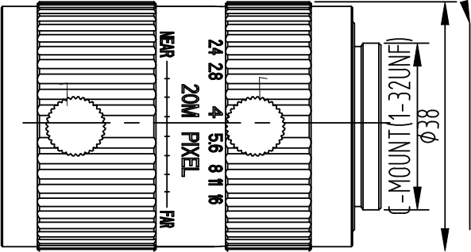

WORKING DISTANCE | OPTICAL  MAGNIFICATION | 1.1”FIELD OF VIEW |  | 1.1" F2.4/16MM /20MEGA/C MOUNT
WORKING DISTANCE | OPTICAL  MAGNIFICATION |  |  | FOCAL LENGTH |  | f=16MM
MM |  | H | V |  |  | f=16MM
5000 | 0.003X | 4259.51 | 3194.633 | F.NO |  | F=1:2.4--16
2000 | 0.008X | 1718.121 | 1288.59 | FOCUS DISTANCE |  | 0.1M-- ∞
1000 | 0.016X | 870.896 | 653.172 |  |  | 0.1M-- ∞
 |  |  |  | FLANGE BACK |  | 17.526mm IN AIR
900 | 0.018X | 786.159 | 589.619 |  |  | 17.526mm IN AIR
 |  |  |  | BACK FOCUS |  | 25.58
800 | 0.020X | 701.417 | 526.062 |  |  | 25.58
700 | 0.023X | 616.665 | 462.499 | FILTER SCREW SIZE |  | M40.5*P0.5
600 | 0.026X | 531.902 | 398.926 | MOUNT |  | C
500 | 0.031X | 447.119 | 335.339 | REL.ILLUMINATION |  | ≥65%
400 | 0.039X | 362.303 | 271.727 |  |  | ≥65%
 |  |  |  |  |  | FrontΦ34.2 RearΦ16.2
350 | 0.044X | 319.876 | 239.907 |  |  | FrontΦ34.2 RearΦ16.2
 |  |  |  | FIELD OF VIEW | SENSOR 1.1Ⅱ 1Ⅱ 2/3Ⅱ
300 | 0.051X | 277.427 | 208.070 | FIELD OF VIEW
250 | 0.060X | 234.948 | 176.211 | FIELD OF VIEW | D 55.7。 51.5。 36.9。
200 | 0.073X | 192.418 | 144.313 | FIELD OF VIEW | H 46.1。 42.4。 30。
150 | 0.094X | 149.799 | 112.35 | FIELD OF VIEW | V 35.5。 32.5。 22.7。
100 | 0.132X | 107.004 | 80.253 | FIELD OF VIEW

TV DISTORTION <0.3% <0.2% <0.15%

VG-BN1620A

bar fastening screw x3
Image
Surface
Focus tightening screw x3
Light

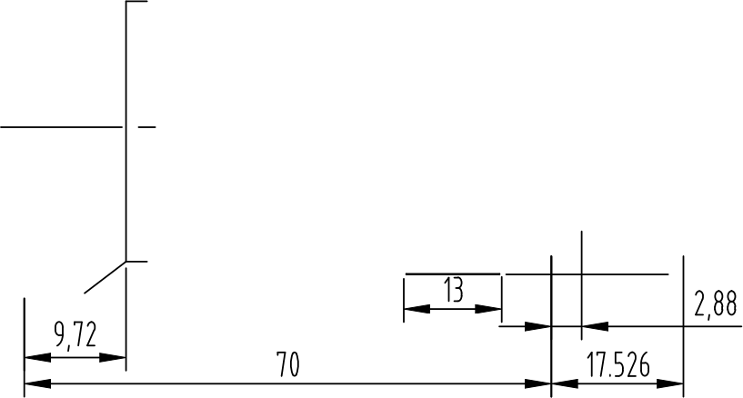

Appearance Standard | 60--40 | WORKING OPTICAL  1.1” FIELD OF  VIEW  DISTANCE MAGNIFICATION
WORKING TEPMERATRUE | -40℃~80℃ | WORKING OPTICAL  1.1” FIELD OF  VIEW  DISTANCE MAGNIFICATION
STORAGE TEPMERATRUE | -40℃~85℃

 | Common Tolerance |  |  |  |  |  |  |  |  |  |  |  |  |  | Material:  / |  | ##
 | Angle | ±0.5°
 |  |  |  |  |  |  |  |  |  |  |  |  |  |  | 3RD_ANGLE_PROJN  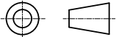 |  | Model:  1.1"-16mm-20M
 | 0.000 | ±0.01
 | 0.000 |  |  |  | Rev |  | Description |  |  |  | Name |  |  | Date
 | 0.00 | ±0.03
 | 0.00 |  |  |  | Design |  |  | Examine |  | Checked |  |  | Approved |  | Unit | mm | Part Name:  VG-BN1620A SPEC
 | 0.0 | ±0.05 |  |  |  |  |  |  |  |  |  |  |  |  | Scale | 2:1
 | 0.0 |  |  |  |  |  |  |  |  |  |  |  | CHKP
 |  |  |  |  |  |  |  |  |  |  |  |  |  |  | Ver | 00 | Dwg No:  VG-BN1620A
 | 0 | ±0.1
 |  |  |  |  |  |  |  |  |  |  |  |  |  |  | Date | 2021.10.10

